**Testing CenW**

**Windows/Linux**

There are no significant differences running CenW in linux or windows. There is some inherent noise in the program so even if the same scenario is run multiple times they will be slightly different. This explains the slight differences running the same scenarios in linux and windows

Runs

* Default
* Our clim
* 15

**Starting dates**

Changing the starting date does not affect the data significantly. All the data have the same trends.

Runs

* Our clim
* 15
* 30
* 45
* 60
* 75
* 90

**Events**

Run the various scenarios with different events to see how much they will affect the output if at all so that we can determine what is important to run later. The different climates do not appear to make much of a difference. The length of the rotation also seemed to make little difference 30 years vs 100 years. **It is important to note the scenario starting in 2030 with a 100 year rotation does not have 100 years of daily data so we do not know where it gets its data to continue.**

Runs

* Our climate no mgmt.
* Co2- realised this is kind of wrong. So would be best to ignore.
* Irrigation
* Fertiliser
* Default management

**Northland**

To verify that CenW is producing data that is consistent with other data we pick a point in Northland and compare the output from NZ National Exotic Forestry Database Regional Yield Tables.

Runs

* No mgmt.
* Mgmt.- default
* Thin- thinning only
* Thin 6/13- change years of thinning to 6 and 13

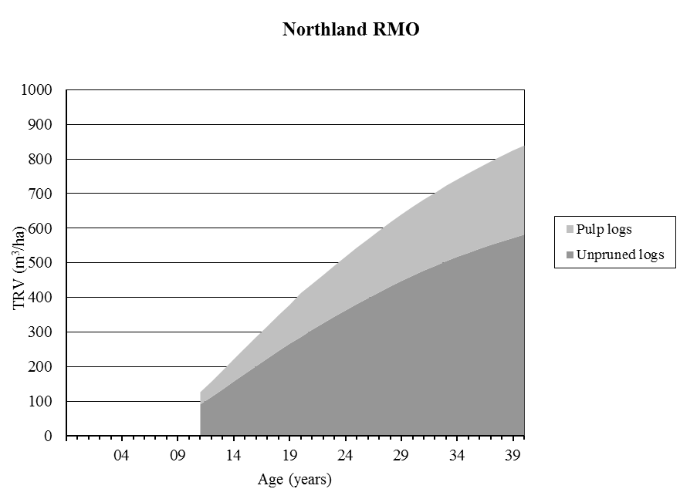

Where northland RMO is unpruned without production thinning ie similar to no management

**Change in rotation length**

See what happens when we give CenW the same climate but chop the trees down at various times ie never, 30, 50 or 70 years later. Needed to check that the intial data were not too different.

**CO2 concentration**

Set the CO2 in climate file ie next column and check that it works in both windows and linux. It does but there are certain options to be selected. File/ read weather data and also Parameters/ Weather which causes a change in the .PJ file.

**What’s left to decide**

We need to decide

* what management options to run ie thinning and pruning for the whole of nz
* figure out how it handles data from when it runs out of daily weather data- though this should not be a problem for us as we have 1972-2100 daily data?
* how to add daily CO2 concs to the .CL file. Using SWIFT?
* Need a bunch of different .PJ files with specifics relating to runs

**KEY**

Default- using the default .CL, PJ files with no management

Ourclim- 1972-2100 daily climate file from 18763109

15- 1972+15-2100 daily climate file from 18763109

30- 1972+30-2100 daily climate file from 18763109

45- 1972+45-2100 daily climate file from 18763109

60- 1972+60-2100 daily climate file from 18763109

75- 1972+75-2100 daily climate file from 18763109

90- 1972+90-2100 daily climate file from 18763109

1972- daily climate file from 18763109 ie our clim

2000- daily climate file from year 2000 in 18763109

2030- daily climate file from year 2030 in 18763109

Co2- mostly wrong so ignore. Events/ environment- add 500 at year 15

Irrigation- turn on default irrigation in events

Fertiliser- turn on 500 at year 1

Default management- harvest and thinning- default harv and thinning from CenW 3.1 GUI

Thin- thinning only ie delete pruning from default management

Thing 6/13- change years of default thinning to 6 and 13